MOJÁCAR REINFORCES ROAD SAFETY EDUCATION AMONG PUPILS AT CEIP BARTOLOMÉ FLORES
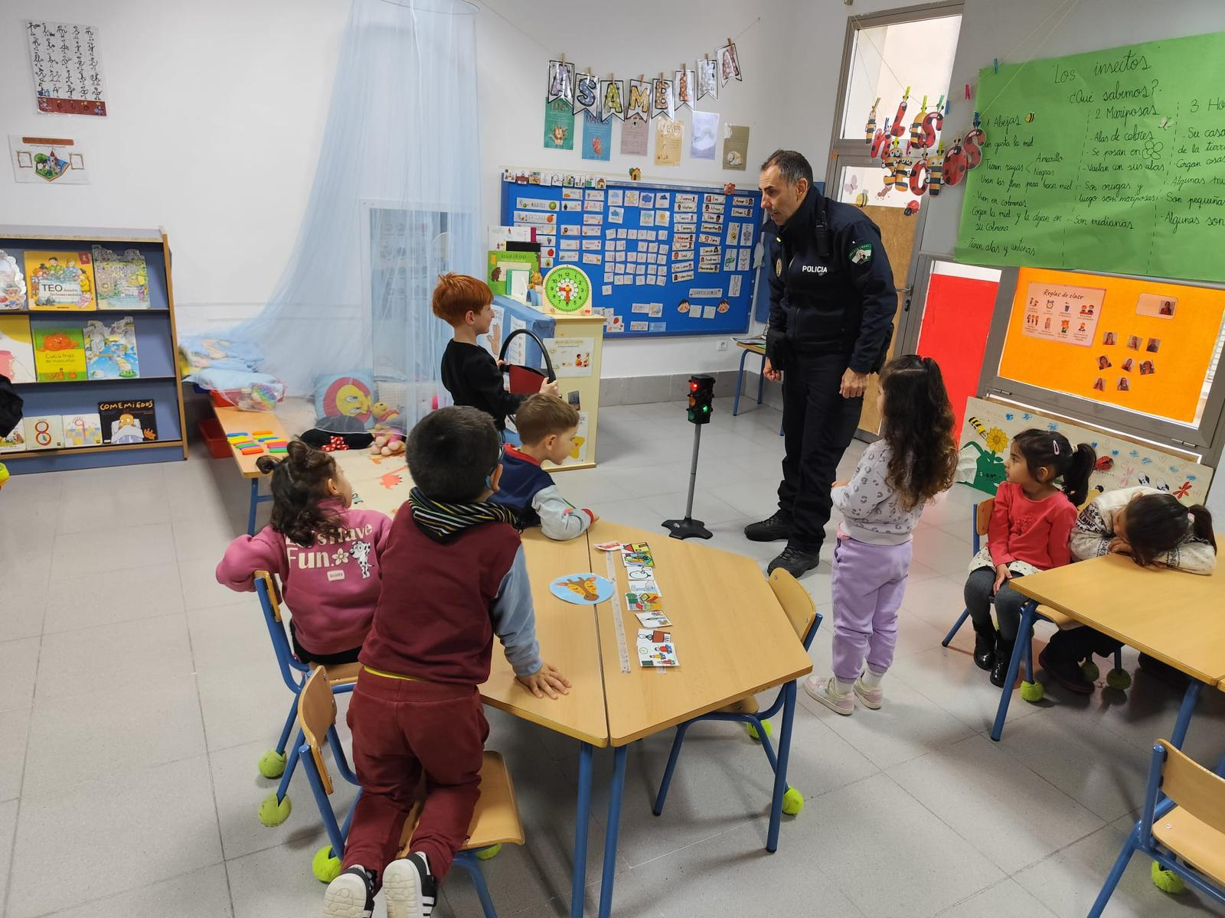
The Mojácar Local Police Road Safety Education Unit has over the last few days run road safety education sessions for Infant and Primary pupils at the CEIP Bartolomé Flores school, with the aim of introducing the youngest children to basic traffic rules and promoting safe mobility habits from an early age.

The sessions, taught by officers specialising in road safety, combined theoretical explanations with practical activities adapted to each educational level. Through interactive activities, games, and everyday examples, the pupils learned to recognise some of the most important traffic signs, understand the importance of respecting traffic rules, and adopt responsible behaviour both as pedestrians and as future drivers.

During the sessions, topics related to safely crossing the road, the correct use of pedestrian crossings, the importance of traffic lights and road signs were also addressed, as well as basic recommendations for riding a bicycle or scooter safely.

During the workshops, topics such as road safety when crossing the street, the correct use of pedestrian crossings, the importance of traffic lights and road signs were also addressed, as well as basic recommendations for riding a bicycle or scooter safely.

The school highlighted the positive reception of the activity by the pupils, who actively took part in the explanations and exercises proposed by the officers, showing great interest in learning how to move safely around the streets.
The Mayor of Mojácar, Francisco García, gave a positive evaluation of this initiative, highlighting the importance of road safety education in the early stages of schooling. “These sessions form part of Mojácar Council's commitment to the safety and education of our young people. Teaching children from an early age to respect traffic rules is fundamental to raising responsible citizens,” he commented.
These sessions make up part of the annual road safety education programme that Mojácar Council, together with the Local Police, run in collaboration with the municipality's educational centres, an initiative that seeks to reinforce awareness and respect for traffic rules among very youngest.

